Registration of payment –2020 International Summer Intensive in Collaboration with Canada’s National Ballet School

Information on how to register your credit card with a profile on Tivoli Ballet School’s website.

Tivoli Ballet School has chosen a payment system, that enables you to pay by Visa, Mastercard, Eurocard and American Express. The system uses a safe gateway called “Quickpay”.

If you have any problems with your profile and registration of credit card, feel free to contact us at balletskolen@tivoli.dk

Go to the website www.tivoli.klub-modul.dk

To register please follow this procedure:

1) Click on the “Opret profil”
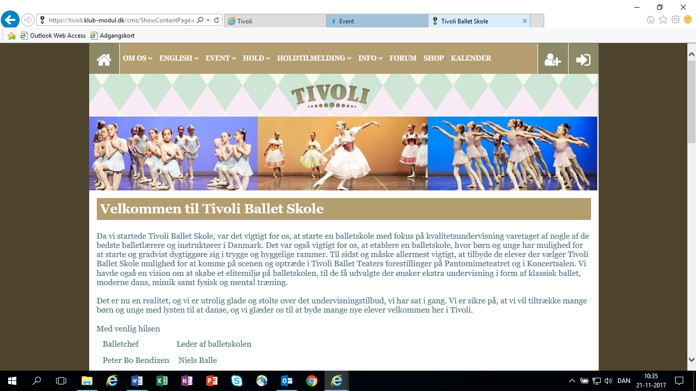

If you already have a profile registered, please go to page 4 in this guide.

- Fornavn: Here you write the students first name
- Efternavn: Here you write the students surname
- Adresse: Here you write the students address
- Postnr. + By: Here you write the students postal code and city
- Hjemkommune: Here you choose the ”Non-Danish” option
- Mobil tlf: Here you write the mobile phone number
- Ekstra mobil: Extra mobile phone number
- Fastnet tlf: Here you write the home telephone number
- Fødselsdato: Birth date DD-MM-YEAR(Like this 24-02-1978)
- Køn: Gender - Mand/male Kvinde/Female
- Email: Email of the student
- Email igen: Email again
- Ekstra email: Extra email
- Ekstra email 2: Another extra email
- Ønsker ikke nyhedsbrev : Do not wish the news letter
- Brugernavn: User name (Minimum 7 letters or – @)
- Password: Password of minimum 7 letters and can not be same as the user name.
- Click on “Opret profil” (create profile) .

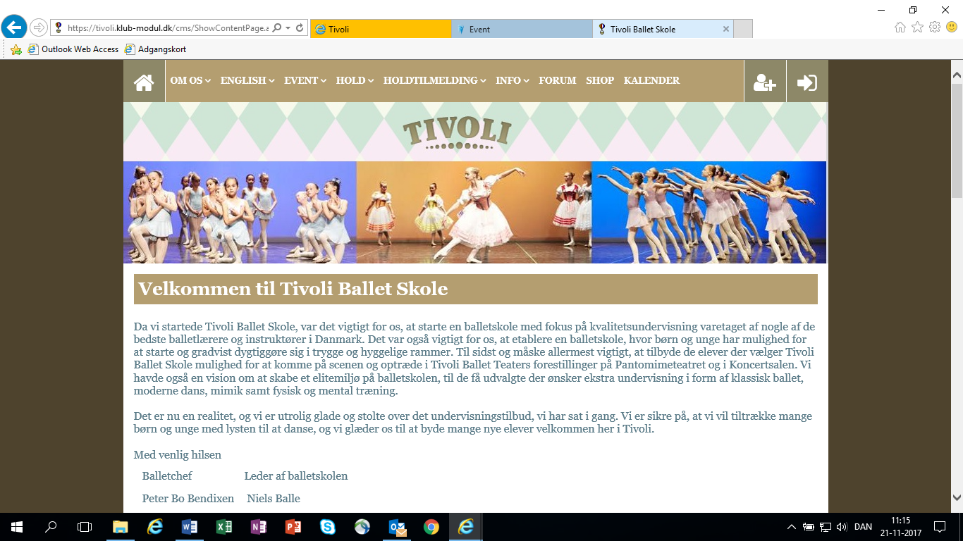
- Go to the front page again
- Log in using your username (Brugernavn) and password
- Here you click on “Event” in the top of the front page

1. Here you click on LÆS MERE & TILMELD under NBS International Summer Intensive 2018 Scroll down to the bottom of the page (remember to fill in the application form and send it by email)

Click on “Jeg accepterer betingelserne”/ “I accept the conditions” and afterwards on “Betal her”/ “Pay here”.
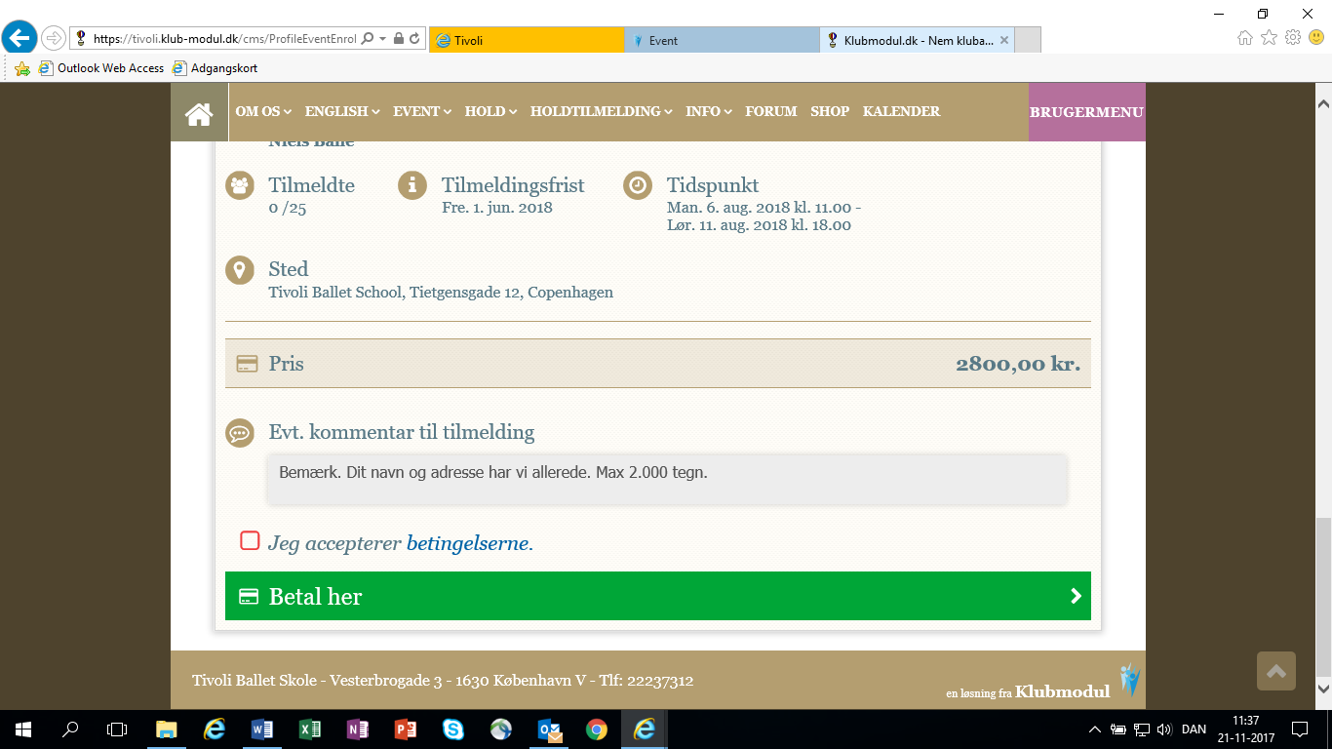
- Choose your credit card

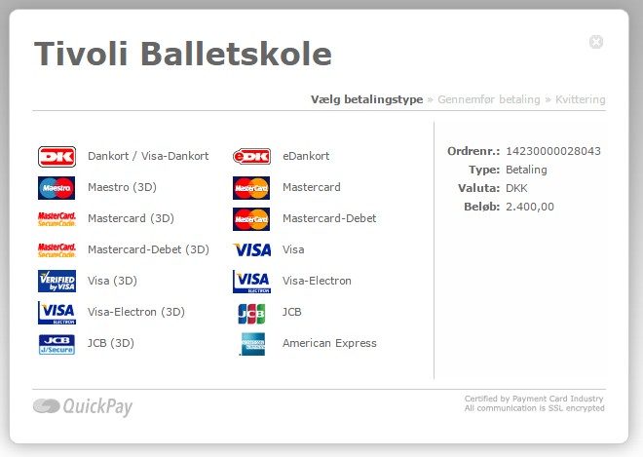

- Kortnummer: Enter your card number
- Udløbsdato: Enter expiration date
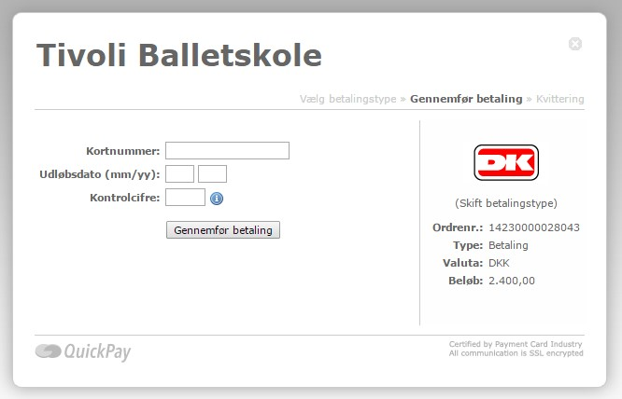
- Kontrolcifre: Enter control numbers
- Finally press Gennemfør betaling/finalize payment

Now you are registered for the
International Summer Intensive 2020 and the amount of 3000 Danish Kroner (DKK) will be transferred from your credit card.

A confirmation will be sent to your email adress.

