Photo audition requirements for International Summer Intensive:

Female applicants please include the following photos:
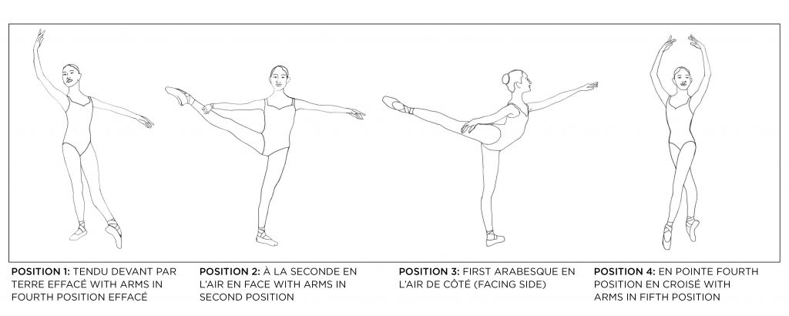
Male applicants please include the following photos:
