 | Application Form: 2020 Summer Intensive in collaboration with Canada’s National Ballet School  Please complete in BLOCK CAPITALS and return scanned to AHJP@tivoli.dk.  Tivoli Ballet School, Vesterbrogade 3, 1630 Kbh. V. DK |  |  |  |  |  |  |  |  |  |  | Please paste one passport sized photo here
- Personal details
First Name |  |  |  | Last Name |  |  |  |  |  |  |  | Male/Female
Date of Birth  (DD/MM/YYYY) |  |  |  | Nationality |  |  |  |  |  |  |  | Height
Address

Post Code |  |  |  |  |  |  | Country
Student Mobil |  |  |  |  |  |  | Student Email
Parent/Guardian First Name |  |  | Parent/Guardian Last Name |  |  |  |  |  |  | Mother/Father/Guardian  Please circle as appropriate
Parent/Guardian Mobil |  |  | Parent/Guardian Email |  |  |  |  |  |  | Emergency contact Mobil
- Ballet Training (please give details of your most recent dance training)
Name of Current Dance Teacher |  |  | Address of Dance School |  |  |  |  |  | Since when
- Level of Training (please specify your current level of ballet training)
Awarding Organisation (e.g. RAD, ISTD) |  |  | Level |  |  |  |  |  | Hours per week
- Additional Training (please tick as appropriate)
 |  | Yes |  |  | No | If Yes, please state how many years of study and hours per week
Pointe Work
Contemporary
- Health Declaration (please provide details of any injuries or health conditions we should know)
 |  | Yes |  |  | No | If Yes, please provide details as appropriate
Food allergies/dietary needs
Injuries
Health Conditions/allergies
- General Information
Do you wish to receive details about future courses at Tivoli Ballet School? |  |  |  |  |  |  |  |  |  |  | Yes |  | No
How did you hear about the Course/Seminar/Summer Intensive?

Current Dance Teacher Signature |  |  |  |  |  |  |  | Date
Parent/Guardian Signature |  |  |  |  |  |  |  | Date

Female applicants please include the following photos:
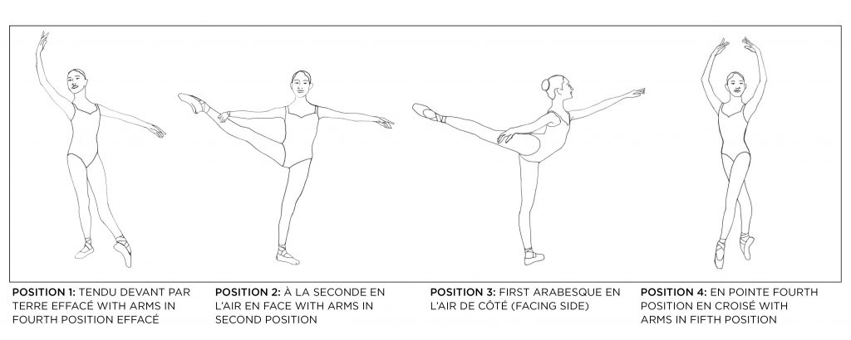
Male applicants please include the following photos:
